

**Source Code Lab**

**Name: Deepak.S**

**Branch: B.Tech**

**Section: CSE**

**Course: Source Code Management**

**SEN: A86605223020**

**Submitted To: Dr. Monit Kapoor**

**Date of Submission: 6 June 2025**



Amity School of   
Engineering & Technology

**COMMANDS IN GIT**

1. **pwd**
   * *Purpose*: Displays the Present Working Directory.
   * *Usage*: Use this to find the directory you're currently working in.

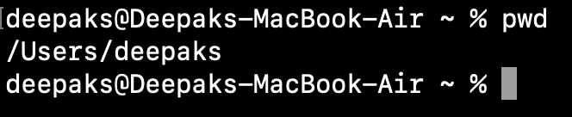

1. **cd**
   * *Purpose*: Change directory.
   * *Usage*: Navigate to a different directory

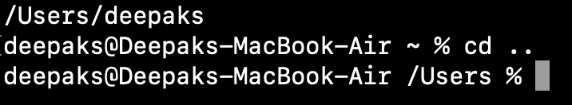

1. **ls**
   * *Purpose*: Lists all folders in the current directory.

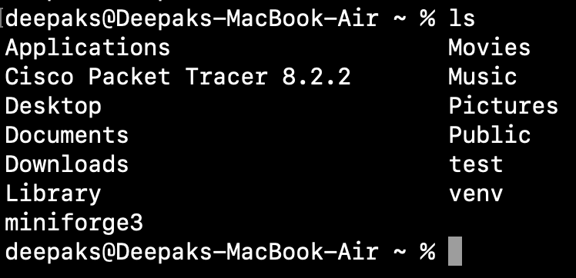

1. **vi**
   * *Purpose*: Open the Vim/Vi editor to create or edit files.
   * *Usage*: vi filename. Press I to insert, esc to exit insert mode, and :wq to save and quit.
2. **cat**
   * *Purpose*: View file contents.
   * *Usage*: cat filename.

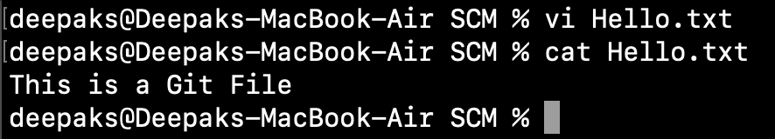

1. **ls -l**
   * *Purpose*: Lists files in long format with additional details (permissions, owners, size).

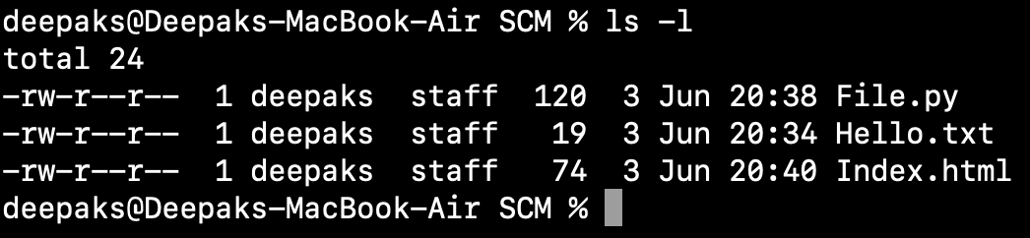

1. **ls -ah**
   * *Purpose*: Lists all files, including hidden ones.

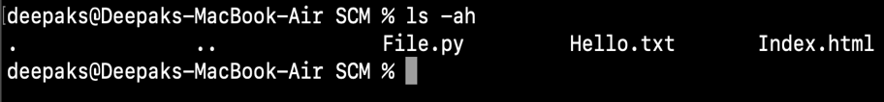

1. **history**
   * *Purpose*: Displays the history of previously run commands.

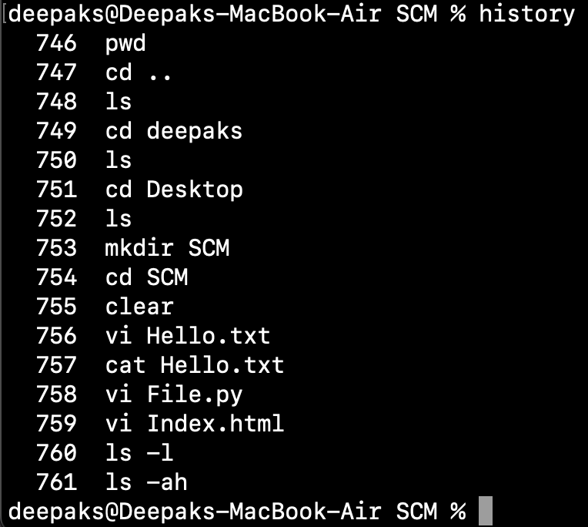

1. **mkdir**
   * *Purpose*: Create a new folder.
   * *Usage*: mkdir foldername.

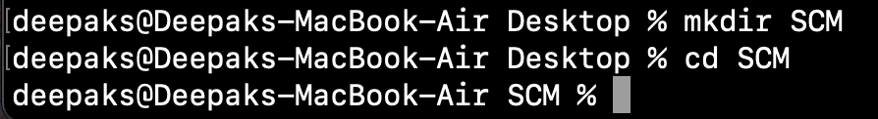

1. **git init**
   * *Purpose*: Initializes an empty Git repository in the current directory.

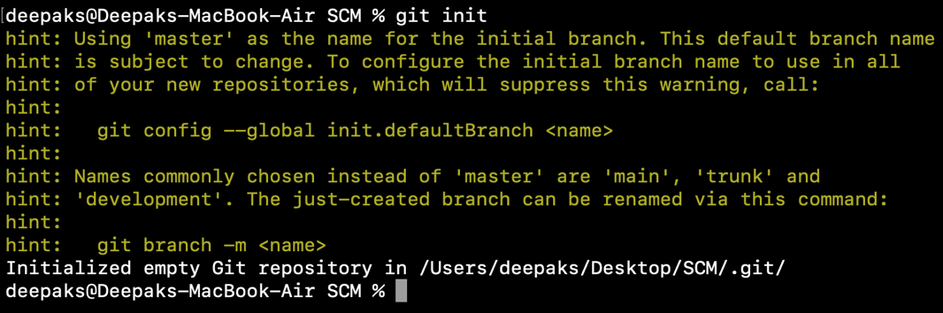

1. **git status**
   * *Purpose*: Displays the current status of the working directory and staging area, showing:
   * Modified files not yet staged.
   * Staged files ready for commit.
   * Untracked files.
   * Current branch and whether it's up-to-date with the remote branch.

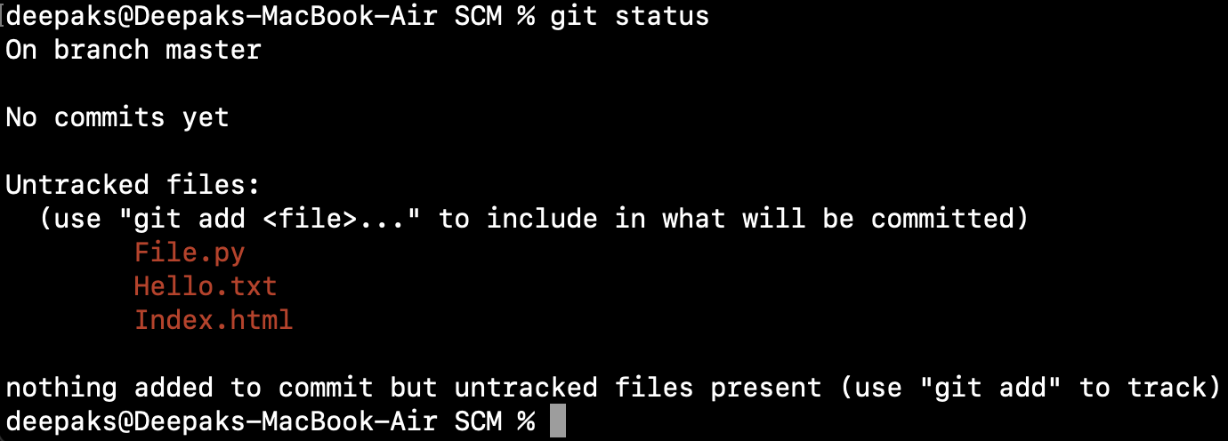

1. **git add**
   * *Purpose*: Stage a file to prepare it for commit.
   * 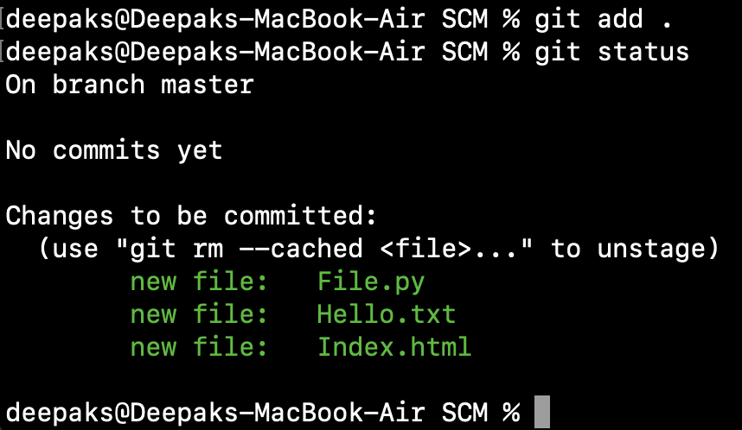*Usage*: git add filename.

13**.git commit**

* + *Purpose*: Commit changes to the repository with a message.
  + *Usage*: git commit -m "Message".

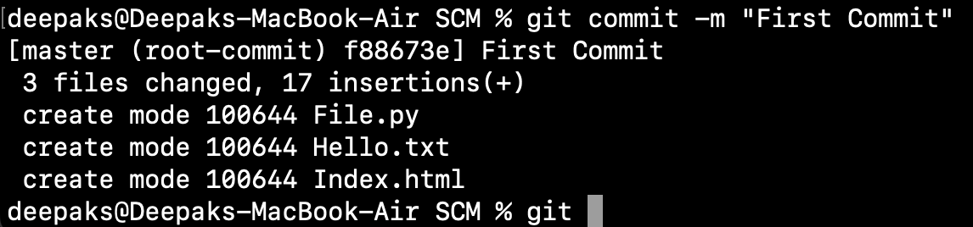

1. **git config**
   * *Purpose*: Configure Git with username and email.
   * *Usage*:
     + git config --global user.mail "email@example.com"
     + git config --global user.name "Your Namve"
2. **git log**
   * *Purpose*: View commit history.

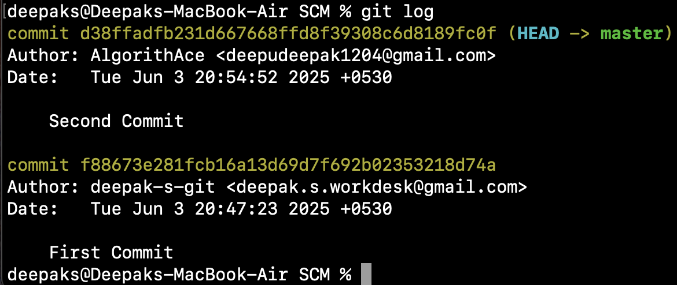

1. **git diff** 
   * *Purpose*: shows the changes made in the working directory since the last commit.
2. **git –oneline**

*Purpose:* View a concise commit history

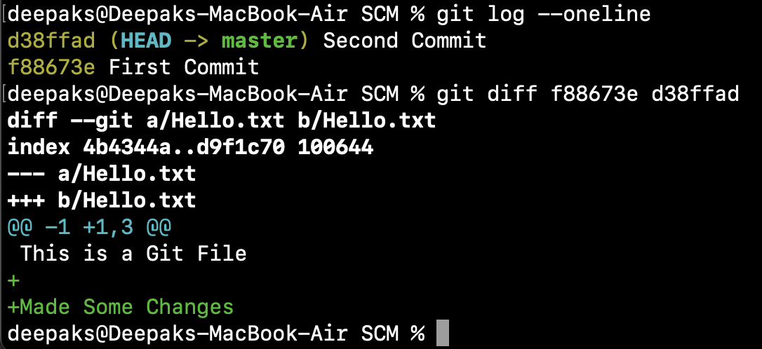

1. **git branch <branch name>**
   * *Purpose*: Creates a new branch.
2. **git branch** 
   * *Purpose*: Lists all branches in the repository.

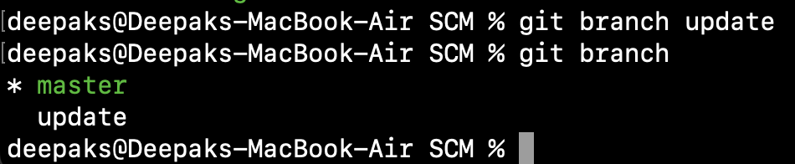

1. **git checkout <branch name>**
   * *Purpose*: Switch to the master branch.
   * *Usage*:

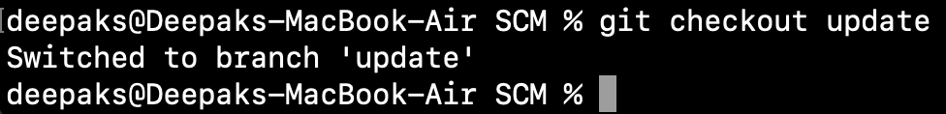

1. **git remote add <url>**

* *Purpose:* Connects your local repository to a remote repository.

1. **git remote**

* *Purpose:* Lists the short names of all configured remote repositories.

1. **git remote -v**

* Purpose: Displays the URLs of all remote repositories linked to your local repository, showing both **fetch** and **push** directions.

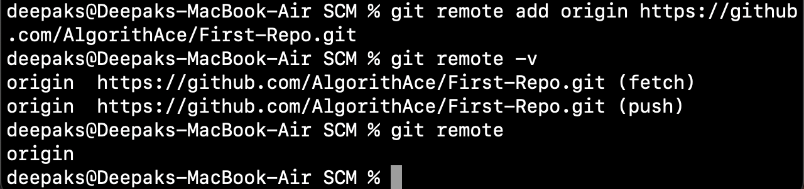

1. **git push**

* 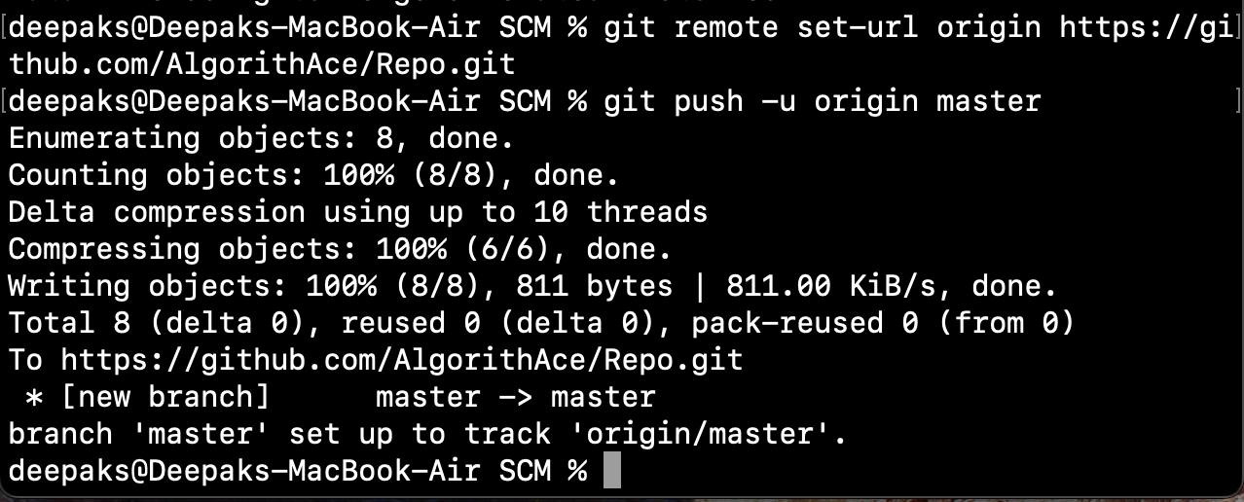Purpose: Pushes the local main branch to the remote repository named origin

**GIT MERGE**

* **Production Code** is the finalized, deployable version of software used in a live environment.
* **Branches** in Git allow multiple versions of code to exist simultaneously, starting from the project's inception.
* **Merging** happens when different branches need to be combined. Git does not automatically decide what to keep—it requires manual resolution.
* **Conflict Resolution**: If conflicts arise, Git will halt the merge. A merge tool helps resolve differences.

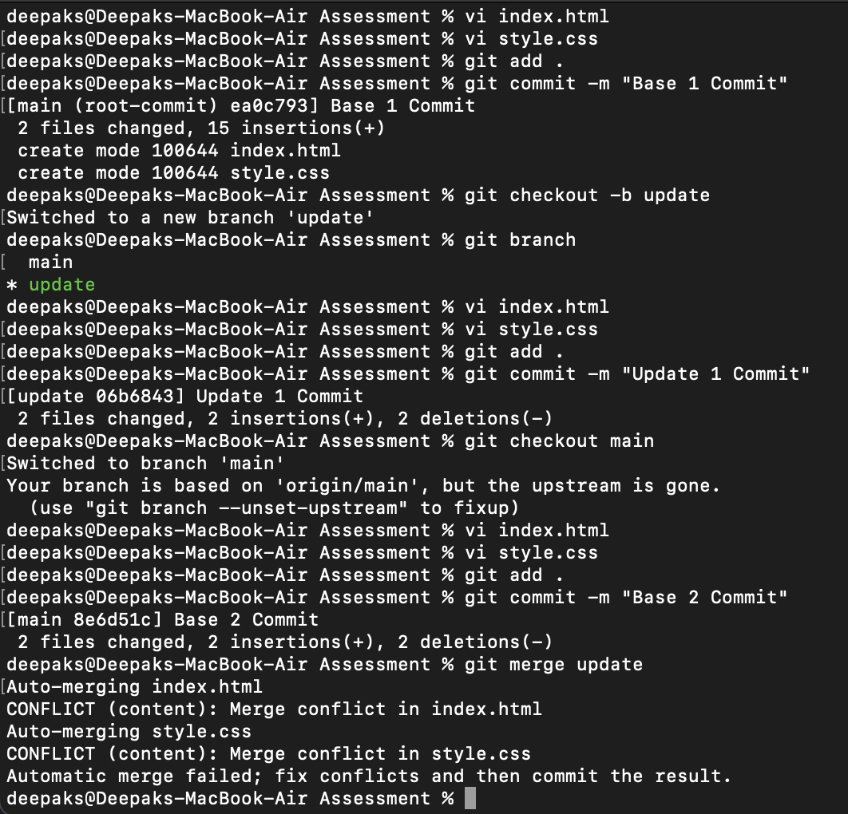

**Handle a simple merge conflict**

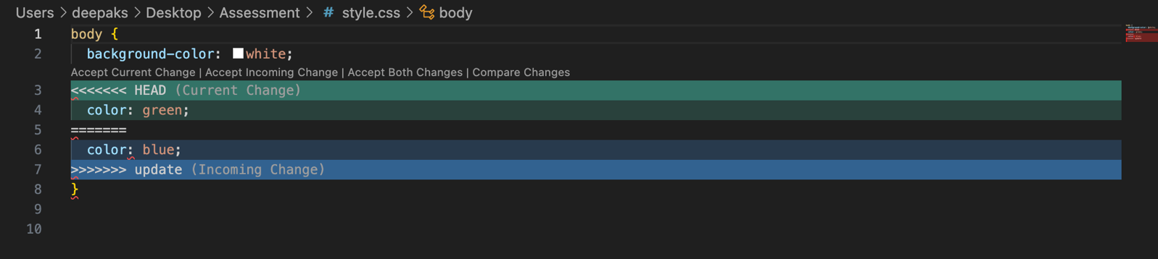

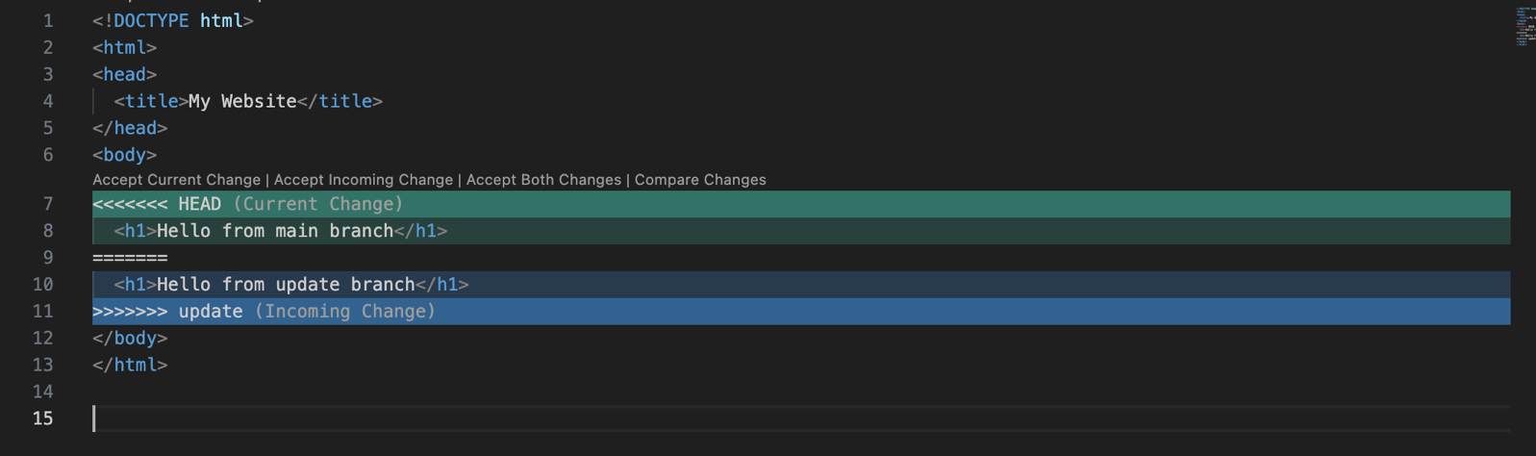

**GIT IGNORE**

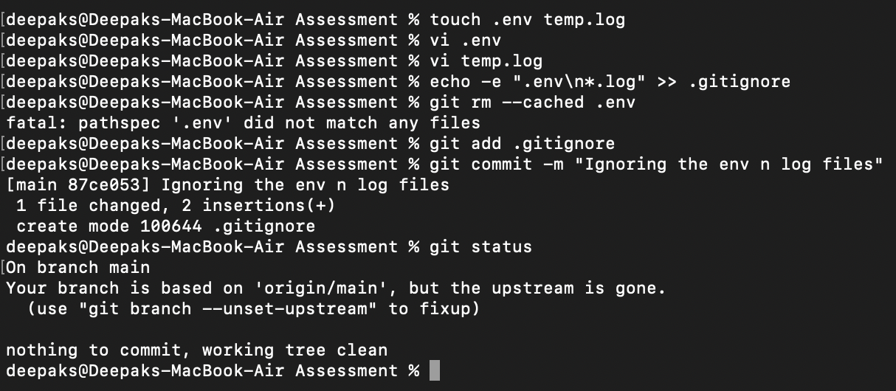

**GIT CLONE**

Navigate a project that you are interested in and fork it

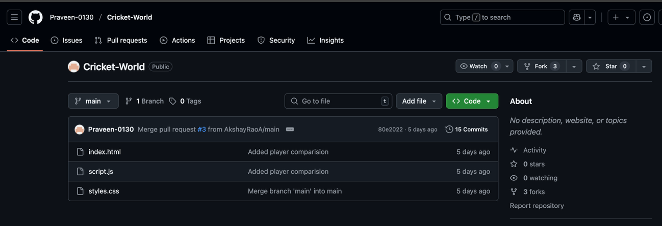

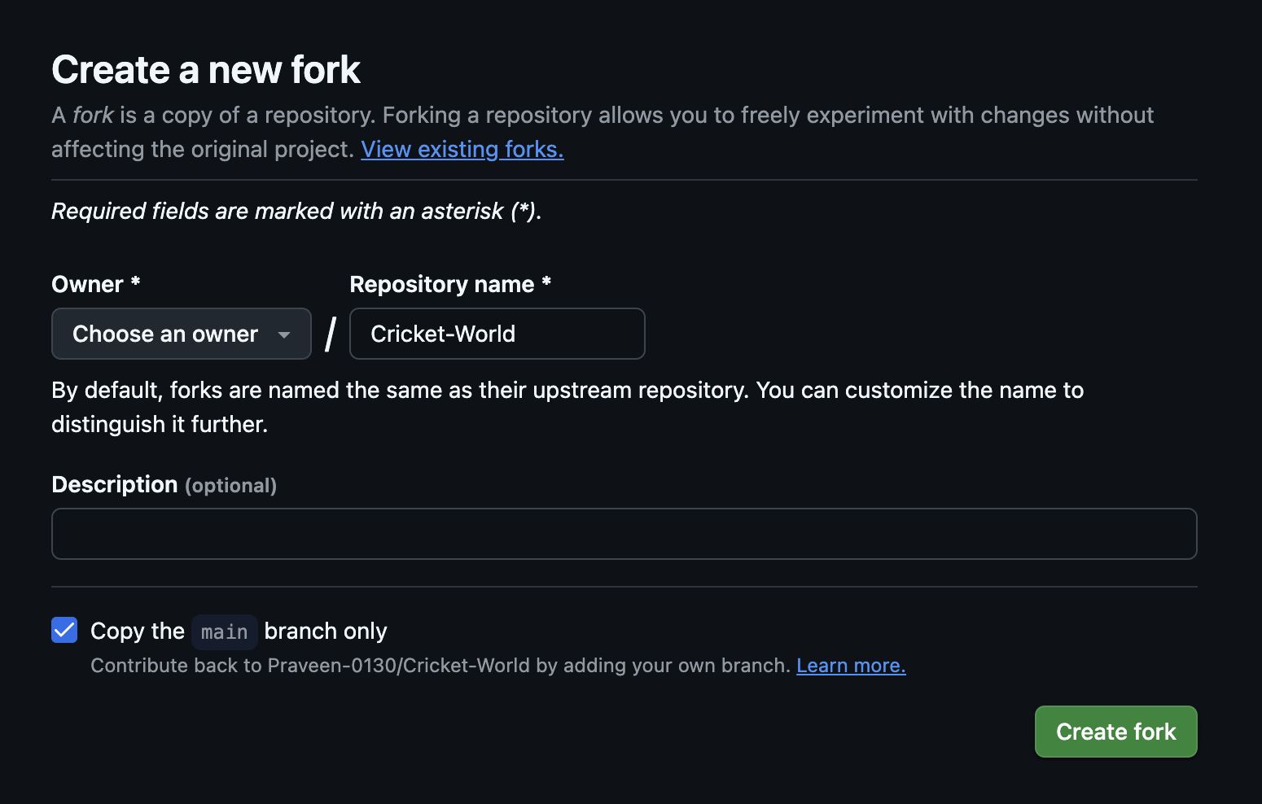

Copy The URL

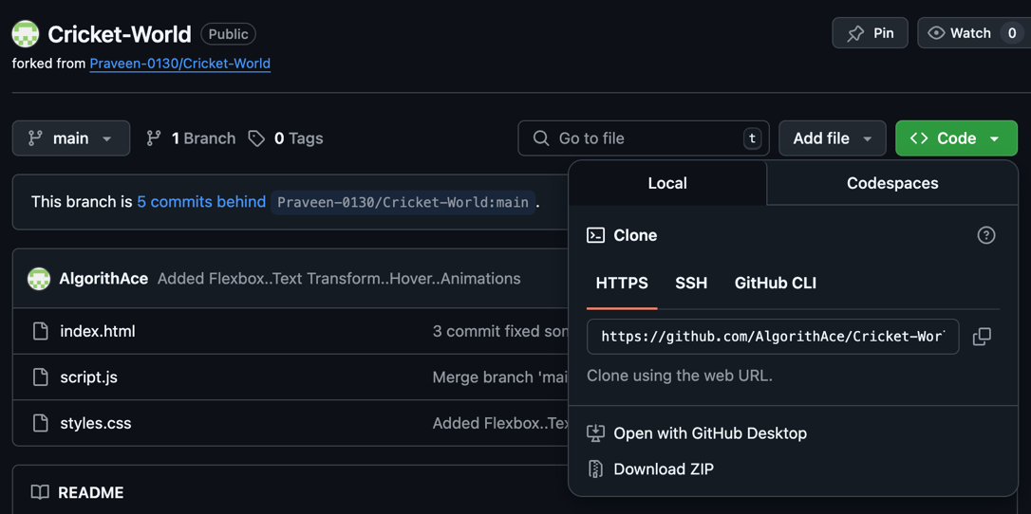

Go to git bash

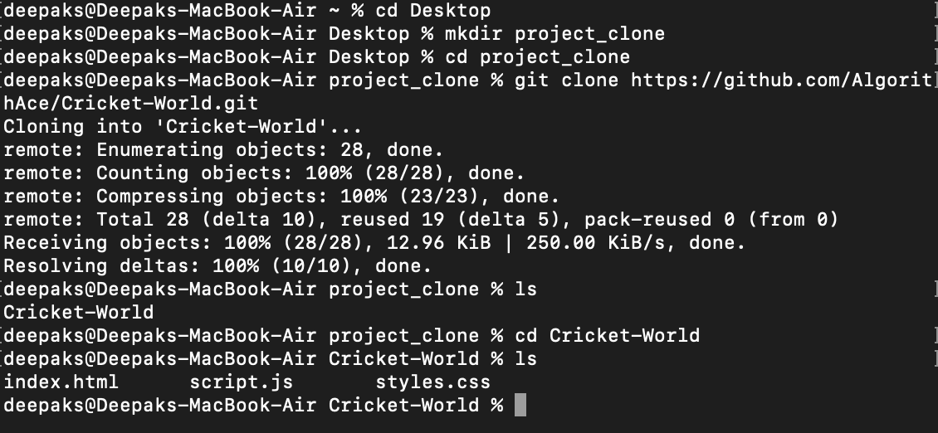

Now the file can be accessed